Linear Regression

The goal of simple linear regression is to create a linear model that minimizes the sum of squares of the residuals / errors (SSE)

<https://www.youtube.com/watch?v=ZkjP5RJLQF4>

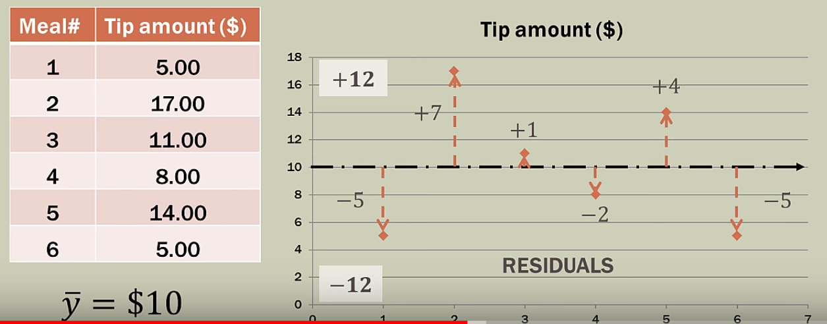

y-bar – mean average

residuals / errors – the distance form real value to its mean value

SSE – Sum of Squared Errors

* Squaring to remove the negativity
* Emphasize larger variations

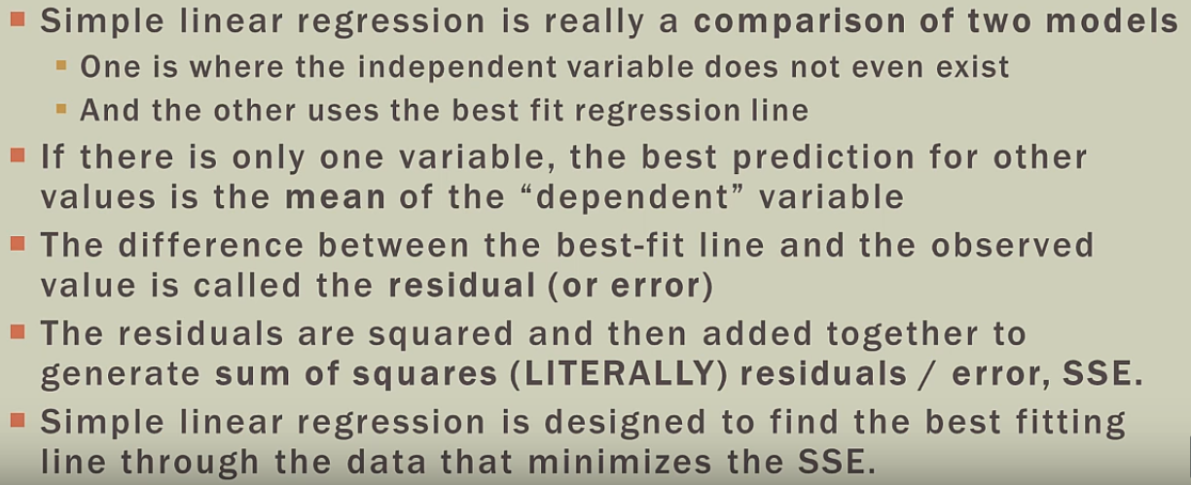

Linear Regression is y = f(x)

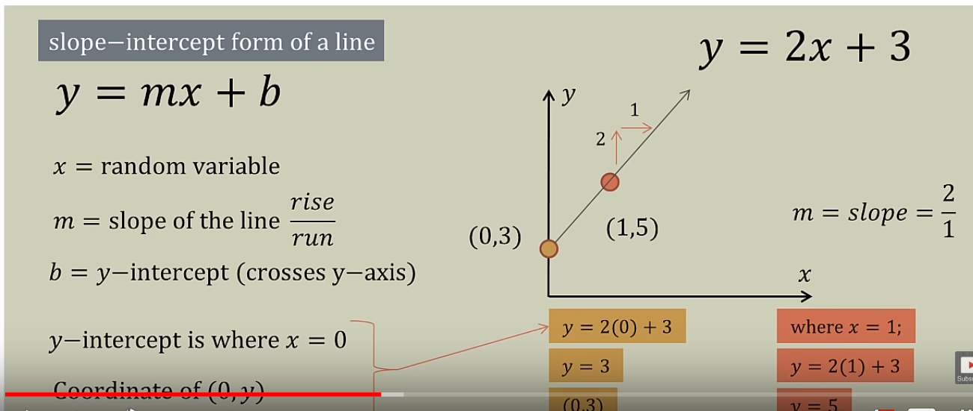

**Variance** is how much a model changes in response to the training data.

**Bias** is the flip side of variance as it represents the strength of our assumptions we make about our data

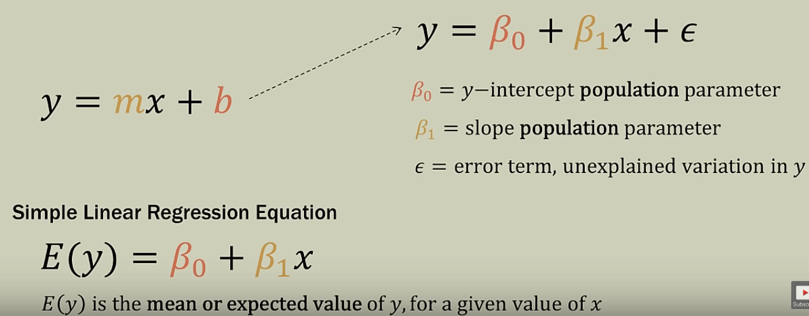

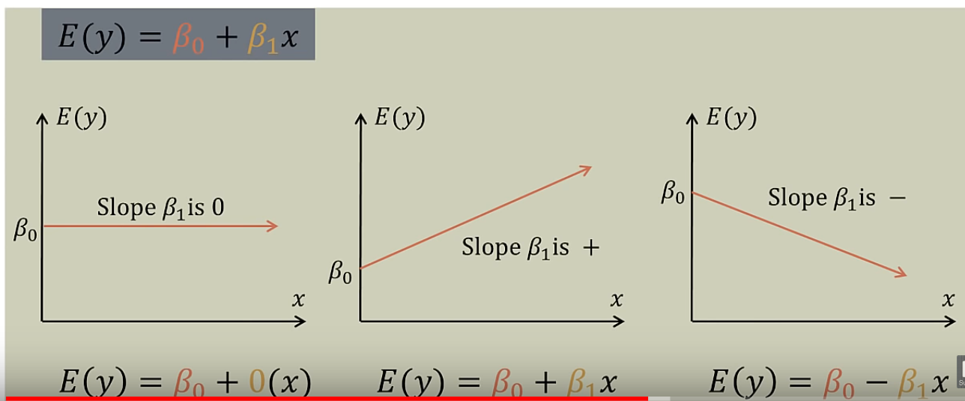

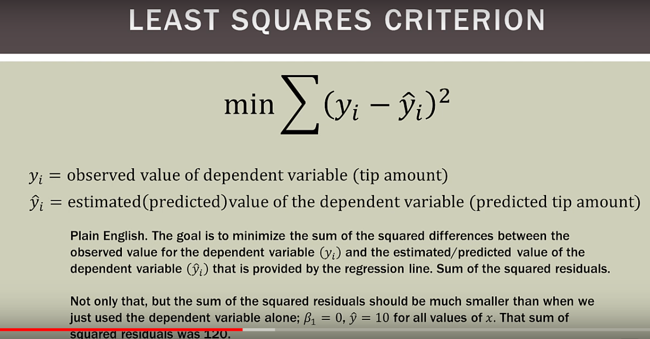

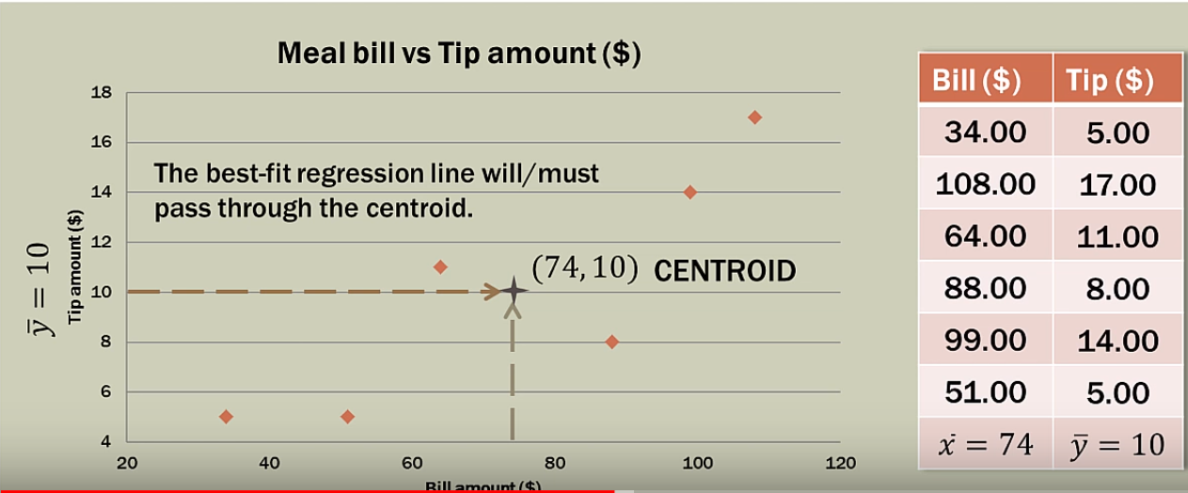

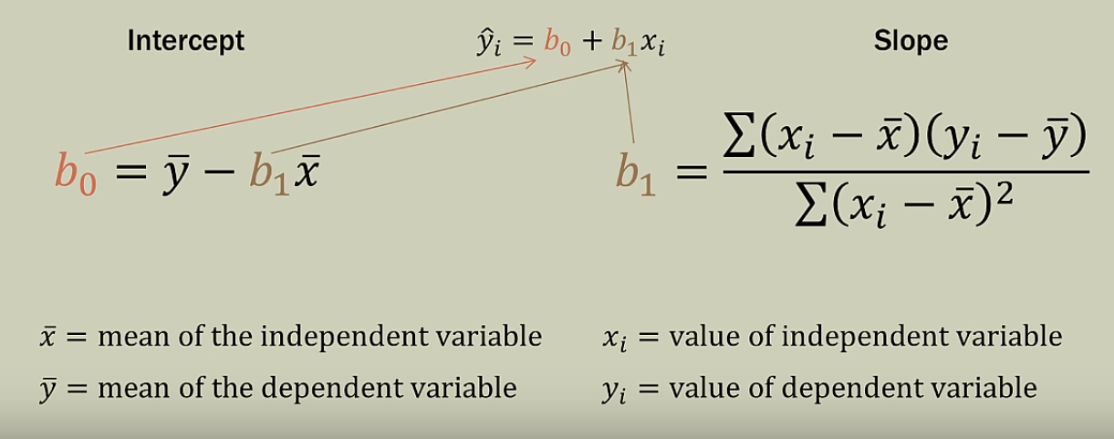

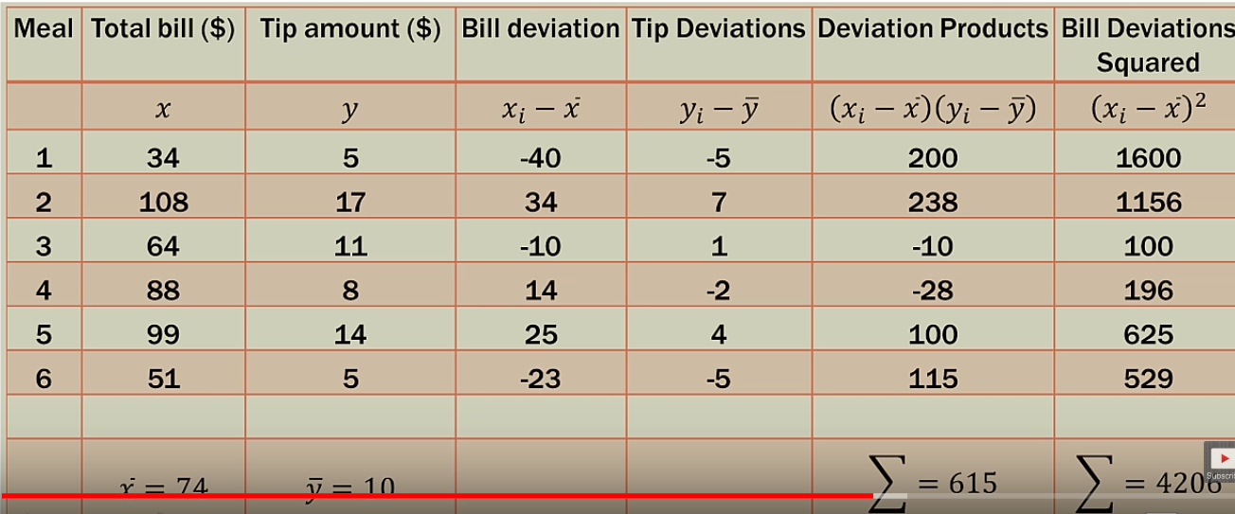

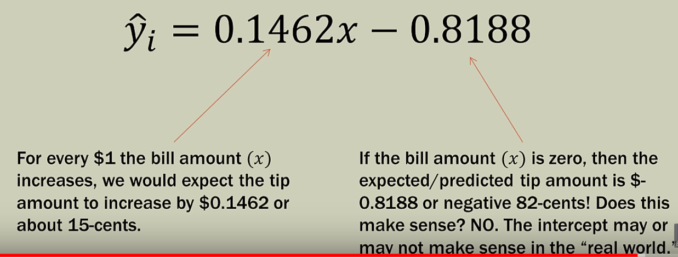

SSE – Sum of Squared Error

SST - Sum of Squared Total

SSR - Sum of Squared Residual

SSR = SST -SSE

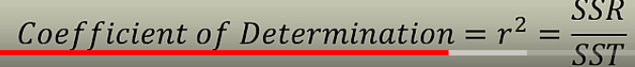

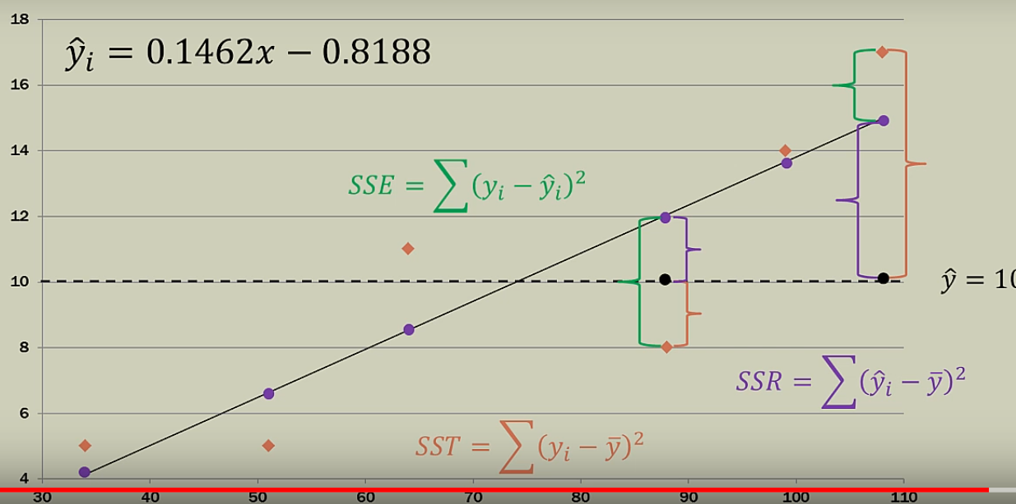

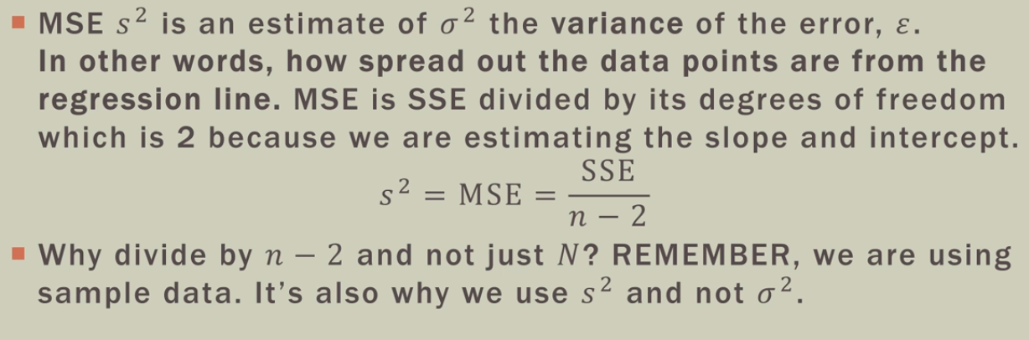

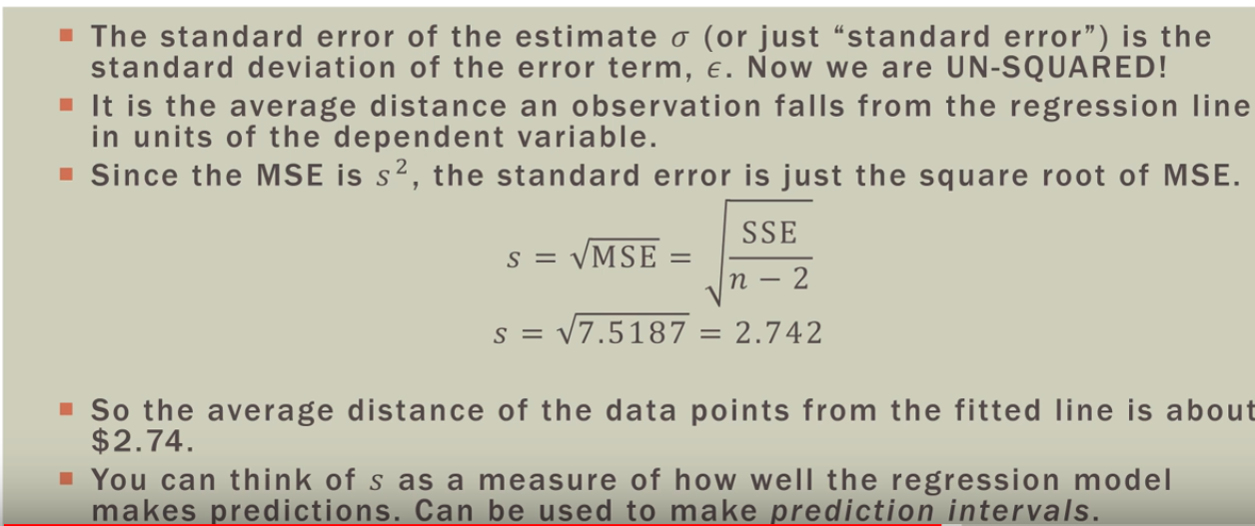

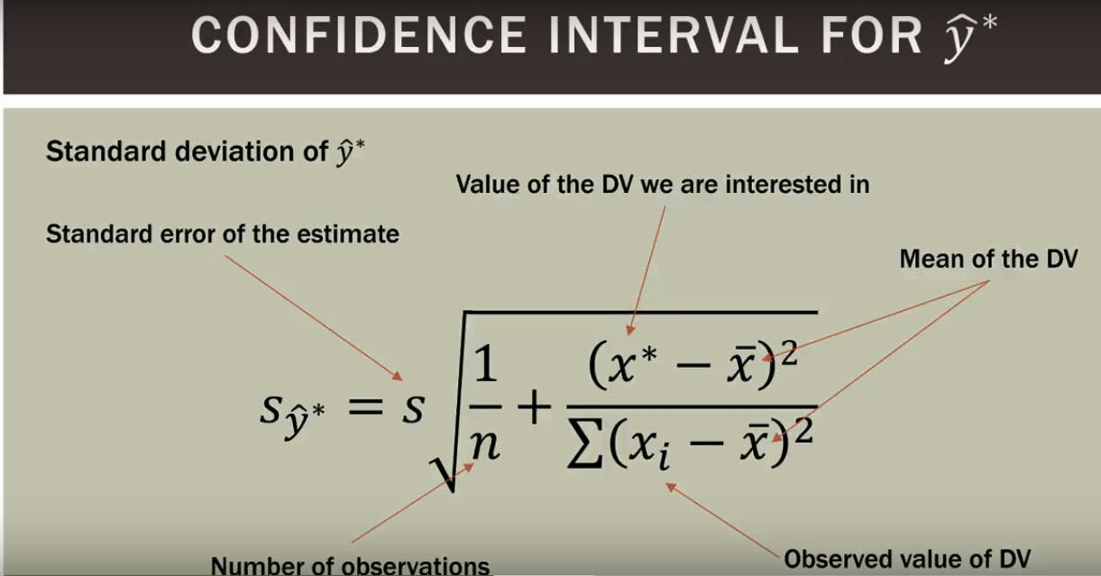

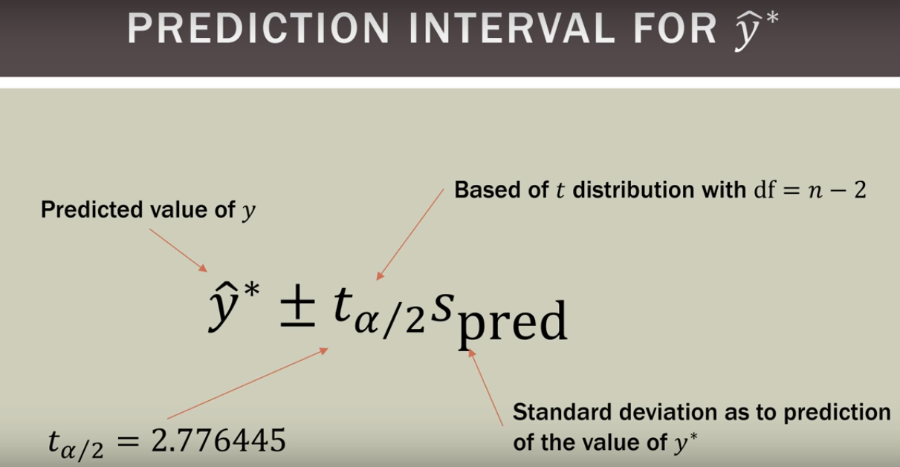

Single Linear Regression:

Y = m x + b;

Multiple Linear Regression:

Y = m1 x1 + m2 x2 + b;

*Polynomial*Regression :

The equation of Quadratic Equation or polynomial of degree 2 is :

https://cdn-images-1.medium.com/max/1600/1*Bg1Zx6fOeL0R8Z9G98A-SA.gif **(Polynomial of degree 2)**

Similarly a Equation of degree 3 :

https://cdn-images-1.medium.com/max/1600/1*A2UDxVqLmv4KkV4yHkZ5EQ.gif(**Polynomial degree 3)**

Polynomial Degree n Would be like:

https://cdn-images-1.medium.com/max/1600/1*PWT0R1EnTIaLSNcWWnItWA.gif(**n degree polynomial)**